Create an app.py folder, and enter the foll:-

from flask import Flask

app = Flask(__name__)

@app.route('/')

def hello():

return 'Hello, World!'

if __name__ == '__main__':

app.run(debug=True, host='0.0.0.0')

Prepared the following dockerfile for the hello-world:-

FROM python:3.9-slim-buster

WORKDIR /app

COPY requirements.txt .

RUN pip install --no-cache-dir -r requirements.txt

COPY . .

EXPOSE 5000

CMD ["python", "app.py"]

Created requirements.txt with the following

Pushed the same to the dockerhub repo ID being

created the docker container using the same dockerfile

docker build -t hello-world .

docker run --name hello-world -d -p 5000:5000 hello-world

Successfully run the hello-world program, and checked the public <URL:5000>

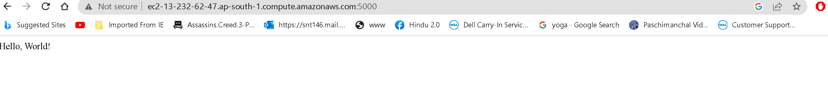

Also documented the same in my github repo i.e. <https://github.com/mohittandon/project-hello-world.git>

Dockerhub repo:-

docker pull mohittndn/hello-world